**LAB-5**

NAME:K.Viswanadh Chowdary

ROLL-No.:22MC3018

T1. Make a simple web page that contains an h2 with the word “Hello” a text input box, and a button. When the user types a word or phrase into the input box and presses the button, replace the old h2 with the word entered. Using animation, make the word spin.

CODE:

<!DOCTYPE html>

<html lang="en">

<head>

<meta charset="UTF-8">

<meta name="viewport" content="width=device-width, initial-scale=1.0"> <title>Document</title>

<style>

body {

font-family: Arial, sans-serif;

text-align: center;

}

#text-container {

margin-top: 50px;

}

#text-container h2 {

transition: transform 0.5s ease;

}

#text-container.active h2 {

animation: spin 1s infinite linear;

}

@keyframes spin {

from {

transform: rotate(0deg);

}

to {

transform: rotate(360deg);

}

}

</style>

</head>

<body>

<div id="text-container">

<h2>Hello</h2>

<input type="text" id="textInput">

<button onclick="changeText()">Change Text</button> </div>

<script>

**function** changeText() {

**var** inputText = document.getElementById('textInput').value; **var** textContainer = document.getElementById('text-container'); **var** heading = textContainer.querySelector('h2'); textContainer.classList.remove('active');

setTimeout(**function**() {

heading.textContent = inputText;

textContainer.classList.add('active');

}, 500);

}

</script>

</body>

</html>

OUTPUT:

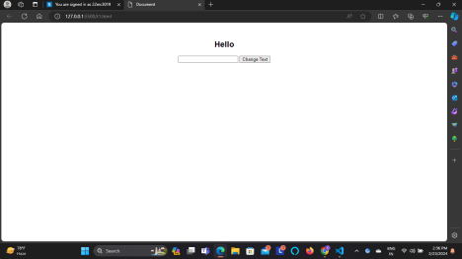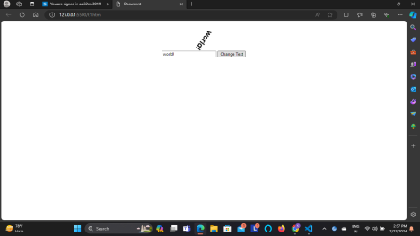

T2. Make a simple web page that contains a button and a paragraph with the id of count Whenever this button is pressed increment the count by 1 and update the paragraph text. Also update the font size so that as the number gets larger, so does the font.

CODE:

<!DOCTYPE html>

<html lang="en">

<head>

<meta charset="UTF-8">

<meta name="viewport" content="width=device-width, initial-scale=1.0"> <title>Document</title>

<style>

body {

font-family: Arial, sans-serif;

text-align: center;

}

</style>

</head>

<body>

<p id="count">0</p>

<button onclick="changeCounter()">Click Me!</button>

<script>

**function** changeCounter() {

**var** countParagraph = document.getElementById('count'); **var** count = parseInt(countParagraph.textContent);

count++;

countParagraph.textContent = count;

**var** fontSize = 16 + count * 2;

countParagraph.style.fontSize = fontSize + 'px';

}

</script>

</body>

</html>

OUTPUT:

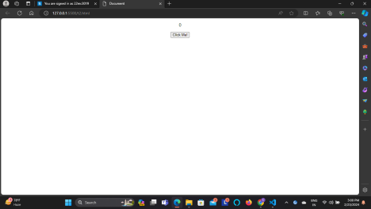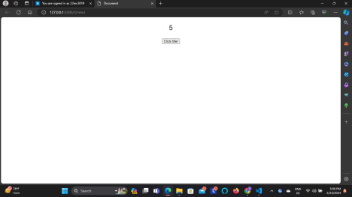

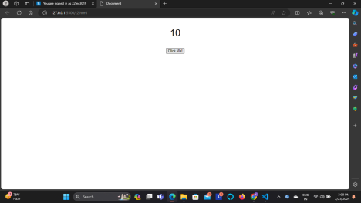

T3. Repeat the previous exercise but make a list of numbers. In this case you will not be able to simply update the innerHTML of the paragraph, you will need to use the document.createElement() and document.appendChild() functions to add a new list item.

CODE:

<!DOCTYPE html>

<html lang="en">

<head>

<meta charset="UTF-8">

<meta name="viewport" content="width=device-width, initial-scale=1.0"> <title>Document</title>

<style>

body {

font-family: Arial, sans-serif;

text-align: center;

}

</style>

</head>

<body>

<ul id="countList">

</ul>

<button onclick="incrementCounter()">Increment</button>

<script>

**var** count = 0;

**function** incrementCounter() {

count++;

**var** countList = document.getElementById('countList');

**var** newItem = document.createElement('li');

newItem.textContent = count;

**var** fontSize = 16 + count * 2;

newItem.style.fontSize = fontSize + 'px';

countList.appendChild(newItem);

}

</script>

</body>

</html>

OUTPUT:

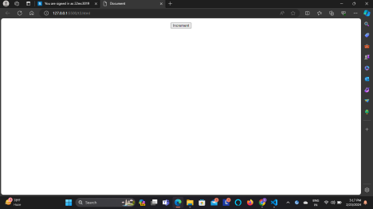

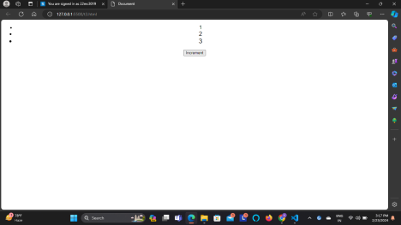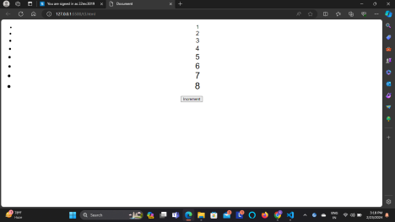

T4. Given the following html. Every time the button is pressed you should add a row to the table, where the new row of the table contains the sum of the previous two rows. You should make use of the lastChild, previousSibling, and innerText attributes in this exercise.

CODE:

<!DOCTYPE html>

<html lang="en">

<head>

<meta charset="UTF-8">

<meta name="viewport" content="width=device-width, initial-scale=1.0"> <title>Document</title>

<style>

table {

border-collapse: collapse;

width: 100%;

}

th, td {

border: 1px solid #ddd;

padding: 8px;

text-align: center;

}

</style>

</head>

<body>

<button onclick="addRow()">one more row click me</button> <table id="myTable">

<tr>

<th>Row Number</th>

<th>Sum</th>

</tr>

</table>

<script>

**function** addRow() {

**var** table = document.getElementById('myTable');

**var** rowCount = table.rows.length;

**var** newRow = table.insertRow(rowCount);

**var** cell1 = newRow.insertCell(0);

cell1.innerText = rowCount;

**var** sum = getSumOfLastTwoRows(table);

**var** cell2 = newRow.insertCell(1);

cell2.innerText = sum;

}

**function** getSumOfLastTwoRows(table) {

**var** rowCount = table.rows.length;

if (rowCount <= 2) {

return 1;

} else {

**var** lastRow = table.lastChild.previousSibling;

**var** secondLastRow = lastRow.previousSibling;

**var** sum = parseInt(lastRow.cells[1].innerText) +

parseInt(secondLastRow.cells[1].innerText);

return sum;

}

}

</script>

</body>

</html>

OUTPUT:

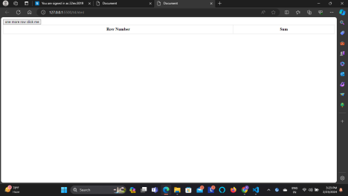

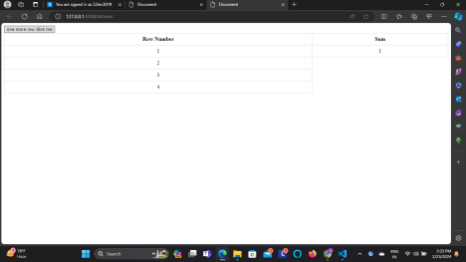

T5. Create an html page with two text input boxes and four buttons. The buttons should be labeled +, -, *, and /. When one of these buttons is pressed you should get the value from both text input boxes and add, subtract, multiply, or divide the numbers entered in the text input boxes. The result should be displayed below the buttons. Note In order to

do math on the values you read from the text input boxes you will need to use Number.parseInt on the value. for example suppose you get a reference to input box 1 using myIn1 = document.querySelector("#in1id"); then the statement value1 = Number.parseInt(myIn1.value) converts the string from the text input box to an integer. In fact most of the time Javascript will do the conversion for you automatically except for addition.

CODE:

<!DOCTYPE html>

<html lang="en">

<head>

<meta charset="UTF-8">

<meta name="viewport" content="width=device-width, initial-scale=1.0"> <title>Calculator</title>

</head>

<body>

<input type="text" id="input1" value="0">

<input type="text" id="input2" value="0"><br><br>

<button onclick="performOperation('+')">+</button>

<button onclick="performOperation('-')">-</button>

<button onclick="performOperation('*')">*</button>

<button onclick="performOperation('/')">/</button><br><br> <div id="result"></div>

<script>

**function** performOperation(operation) {

**var** input1 = document.getElementById('input1').value; **var** input2 = document.getElementById('input2').value; **var** num1 = parseInt(input1);

**var** num2 = parseInt(input2);

**var** result;

switch(operation) {

case '+':

result = num1 + num2;

break;

case '-':

result = num1 - num2;

break;

case '*':

result = num1 * num2;

break;

case '/':

if(num2 !== 0) {

result = num1 / num2;

} else {

result = "Cannot divide by zero";

}

break;

default:

result = "Invalid operation";

}

document.getElementById('result').innerText = "Result: " + result; }

</script>

</body>

</html>

OUTPUT:

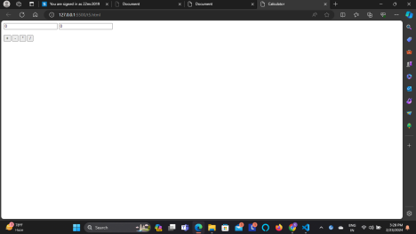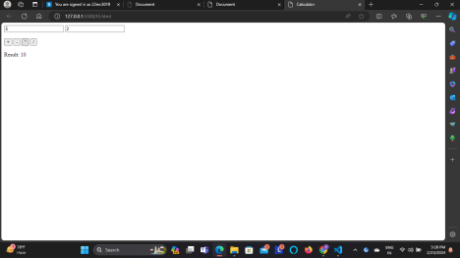

T7. Create a Tip Calculator as a single page web application (SPA). Design an interface that allows you to enter the amount of the tip. The percentage you would like to tip, and the number of people to split the tip with. Do not use 3 text input elements! Calculate and dynamically display the tip.

CODE:

<!DOCTYPE html>

<html lang="en">

<head>

<meta charset="UTF-8">

<meta name="viewport" content="width=device-width, initial-scale=1.0"> <title>Tip Calculator</title>

<style>

body {

font-family: Arial, sans-serif;

text-align: center;

}

.input-group {

margin-bottom: 20px;

}

</style>

</head>

<body>

<h1>Tip Calculator</h1>

<div class="input-group">

<label for="billAmount">Bill Amount: $</label>

<input type="number" id="billAmount" min="0" step="0.01"> </div>

<div class="input-group">

<label for="tipPercentage">Tip Percentage: %</label>

<input type="number" id="tipPercentage" min="0" max="100" step="0.01"> </div>

<div class="input-group">

<label for="numPeople">Number of People:</label>

<input type="number" id="numPeople" min="1" step="1">

</div>

<button onclick="calculateTip()">Calculate Tip</button> <div id="tipAmount"></div>

<script>

**function** calculateTip() {

**var** billAmount = document.getElementById('billAmount').value; **var** tipPercentage = document.getElementById('tipPercentage').value; **var** numPeople = document.getElementById('numPeople').value; if (billAmount && tipPercentage && numPeople) {

**var** tipAmount = (billAmount * tipPercentage / 100) / numPeople; document.getElementById('tipAmount').textContent = "Tip per person: $" + tipAmount.toFixed(2);

} else {

alert("Please enter all required values.");

}

}

</script>

</body>

</html>

OUTPUT:

